Recommendation and Simulation of Medical Diagnostics using Artificial Intelligence

Dhanush Y P  
Department of Computer Science and Engineering  
New Horizon College of EngineeringMarathalli, Bengaluru,   
[dhanushyp@gmail.com](mailto:dhanushyp@gmail.com)

Muskan Rizwan Shaikh   
Department of Computer Science and Engineering  
New Horizon College of EngineeringMarathalli, Bengaluru,   
[muskans0307@gmail.com](mailto:muskans0307@gmail.com)

Yajat Vinod Vishwakarma  
Department of Computer Science and Engineering  
New Horizon College of EngineeringMarathalli, Bengaluru, [yajat472001@gmail.com](mailto:yajat472001@gmail.com)

Surya Pandey  
Department of Computer Science and Engineering  
New Horizon College of EngineeringMarathalli, Bengaluru,   
[suryaspandey@gmail.com](mailto:suryaspandey@gmail.com)

***Abstract*—The healthcare industry is unique in comparison to other industries. It is a high-priority industry, and consumers want the highest level of care and services possible, regardless of the costs involved. Along with its subjectivity, the complexity of the condition, and the wide variations that exist across diverse interpretations, a medical diagnosis by human professionals is severely limited. This paper proposes an architecture for recommendation and stimulation of medical diagnostics in order to assist doctors and other medical professionals in the correct interpretation of a disease. The methodology followed uses the latest artificial intelligence and machine learning models to get precise results. To strengthen the architecture, we have made use of unsupervised learning, clustering and augmentation approaches. The datasets that will be used are imagery data, historic medical records, numeric data charts that describe various data points.**

***Keywords—Machine Learning, Unsupervised Learning, Clustering, Data Augmentation, Medical Diagnostics***

# INTRODUCTION

The science of diagnosis is a difficult task, as it requires the human mind to understand and connect all the information required to solve a problem. In medical diagnosis, the margin for error is zero. Throughout all of human history, we have questioned the very fabric of nature and reality, yet our accuracy in understanding how things work is still not efficient.

Technological advancements over the decades have come with a great promise, however their slow adoption in the medical field is quite surprising. A modern system which has the processing power, and the abundance of data should have paved the way for artificial intelligence to be used in almost every aspect in the field of medicine. But artificial intelligence applications are faced with some challenges, including the black-box nature of some AI models. The poor explainability of these black-box models leads to distrust from medical experts to make explainable clinical inferences [1]. There are often millions of parameters in Deep Learning models, and they only return a final decision result without any explanation. Due to the lack of transparency of deep neural networks, it is hard for the user to judge whether the decision is reliable, compromising trust with doctors.

Algorithms used to identify diseases rely on associative inference. This means that they identify diseases based on how strongly they correlate with a patient's symptoms and medical history. In contrast, doctors perform diagnosis by selecting diseases that offer the best causal explanations for their patients' symptoms.

The application of artificial intelligence within the diagnostic process supporting medical specialists could be of great value for the healthcare sector and the overall patients’ well-being. The integration of artificial intelligence into existing technical infrastructure accelerates the identification of relevant medical data from multiple sources which are tailored to the needs of the patient and the treatment process. Furthermore, artificial intelligence generates results based on a larger population rather than on subjective, personal experiences and achieves equal results when using identical medical data and does not rely upon situations, emotions, or time of day.

In Section 2, we give a literature review which enabled us to write this paper. Section 3 will give a detailed explanation of the proposed system and its models for the analysis of a case, which will make the process reliable and precise. Section 4 includes the results and discussions and finally Section 5 concludes the findings of the research paper.

# LITERATURE REVIEW

The technological landscape has drastically evolved in the last few decades. This has propelled the development of new tools and improvement in our approach to solve problems using computation.

J. Lemley et al. [2] defines smart augmentation as a process in which deep neural networks are trained to determine the best augmentation strategy for a given class of input data. The merged sample is then used to train the target network.

A.D.Dongare et al. [3] interpret ANNs as massive parallel computational models that imitate the function of the human brain. A single computing node alone is not a very powerful computational engine. A single computing node generates a scalar output, which is a simple non-linear function of its inputs.

The use of both smart data augmentation and ANN make it possible to tackle the challenging nature of performing diagnostics in the medical field.

# METHODOLOGY

## Architecture Description

The fundamental approach used to solve a problem of such magnitude often requires the usage of various components working hand in hand. Every intelligent decision making system uses a systematic workflow of how data moves around to provide accurate results. In this architecture(which architecture?, mention fig name) we divide the entire decision making procedure into modular blocks, each of which provides a functional value.

Data is first collected and filtered which is then passed to a decision making block that constantly communicates with all the diagnostics machine learning models. The decision making block is the central nervous system of the entire architecture. It constantly keeps updating its data repositories and maintaining a dialogue between all the individual diagnostic modules. The architecture is backed by a persistent storage module which maintains all the processed data. Finally the end result is validated through a feedback loop which initiates all the modules to calibrate.

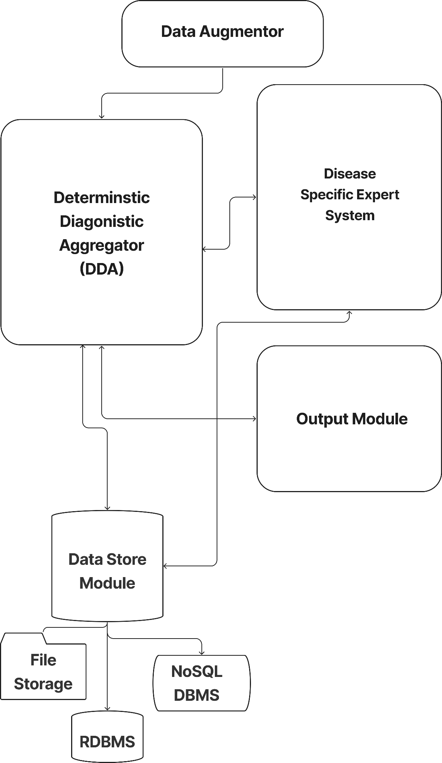

1. Proposed Architecture

## Data Augmentation

Data is everything when it comes to the process of making decisions. There is an abundance of data and with this privilege comes the necessity to classify them into all the types and use the ones that add value. Data can be of different types like, images from X-Ray, MRI etc, historical medical records, numeric data charts describing various data points. With the domain of the data being set, we now validate features that can be used in the workflow later.

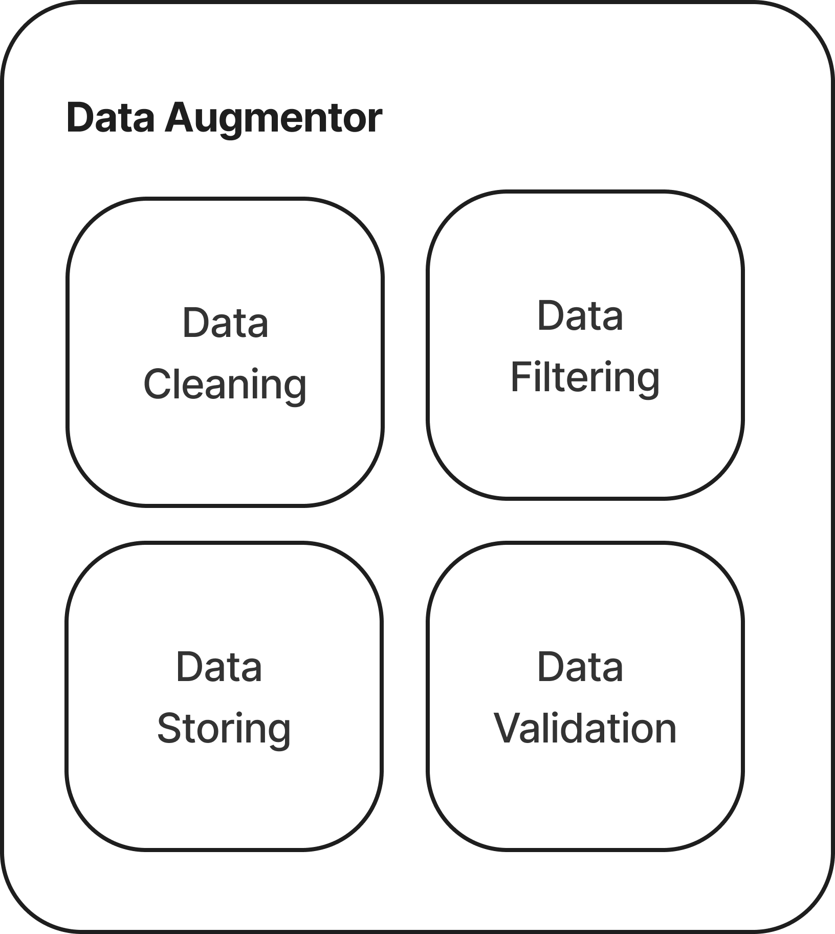

1. Components of Data Augmentor

## Deterministic Diagnostic Aggregator

Even though the entire architecture is modular, there is a need for a centralized decision making body which governs the working of all the individual modules. The Deterministic Diagnostic Aggregator (DDA) plays this role by firstly receiving data from the augmentor and performing pre diagnostic tests to understand the nature of the data with which it then maps to the particular Machine Learning (ML) model which is responsible for analyzing the data points and providing the results. These results are then sent back to the DDA which then verifies it for accuracy and unexplored patterns. DDA itself could be a ML model to classify which disease can be detected in the input data. The DDA reiterates its results and is in a feedback loop that constantly tries to find correlation and patterns in the data. The working of DDA is depicted in Figure .

For instance, if an X-Ray for a test of bronchitis is input to the system, DDA will be able to not only detect if the input data suffers from bronchitis but also detect if any other anomaly exists in the X-Ray. The DDA is tightly coupled with the Disease Specific Expert System (DSES). A more detailed explanation of the DSES can be found in part D of this section.

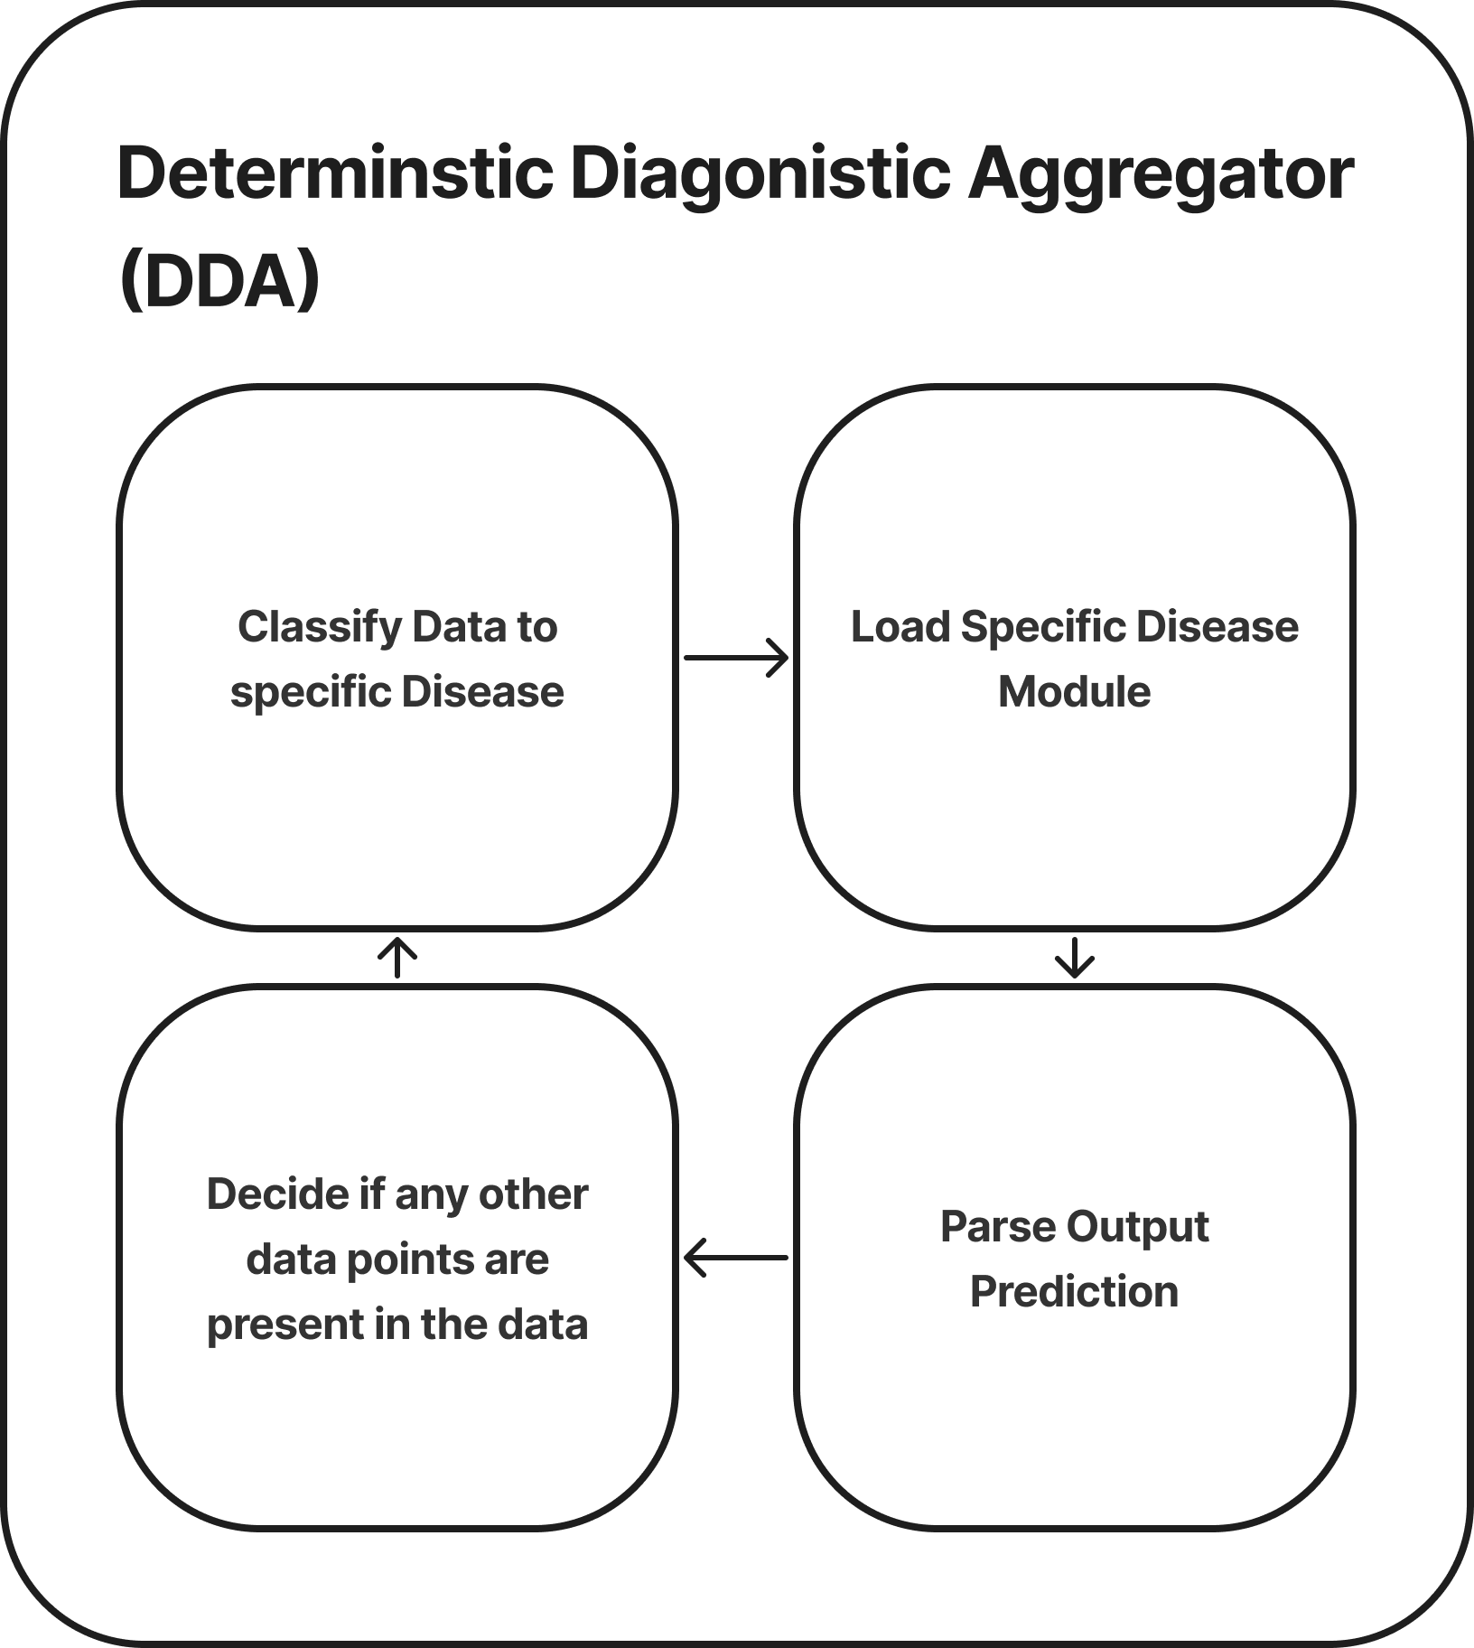

1. Internal functioning of Deterministic Diagnostic Aggregator

## Disease Specific Expert System

Every disease has its own unique identification factors that cannot be generalized and applied to reach a good diagnosis. The use of the DDA which acts as an interface to enable the offloading of decision making to the machine learning model which is best suited allows the existence of models that are specific to a particular disease.

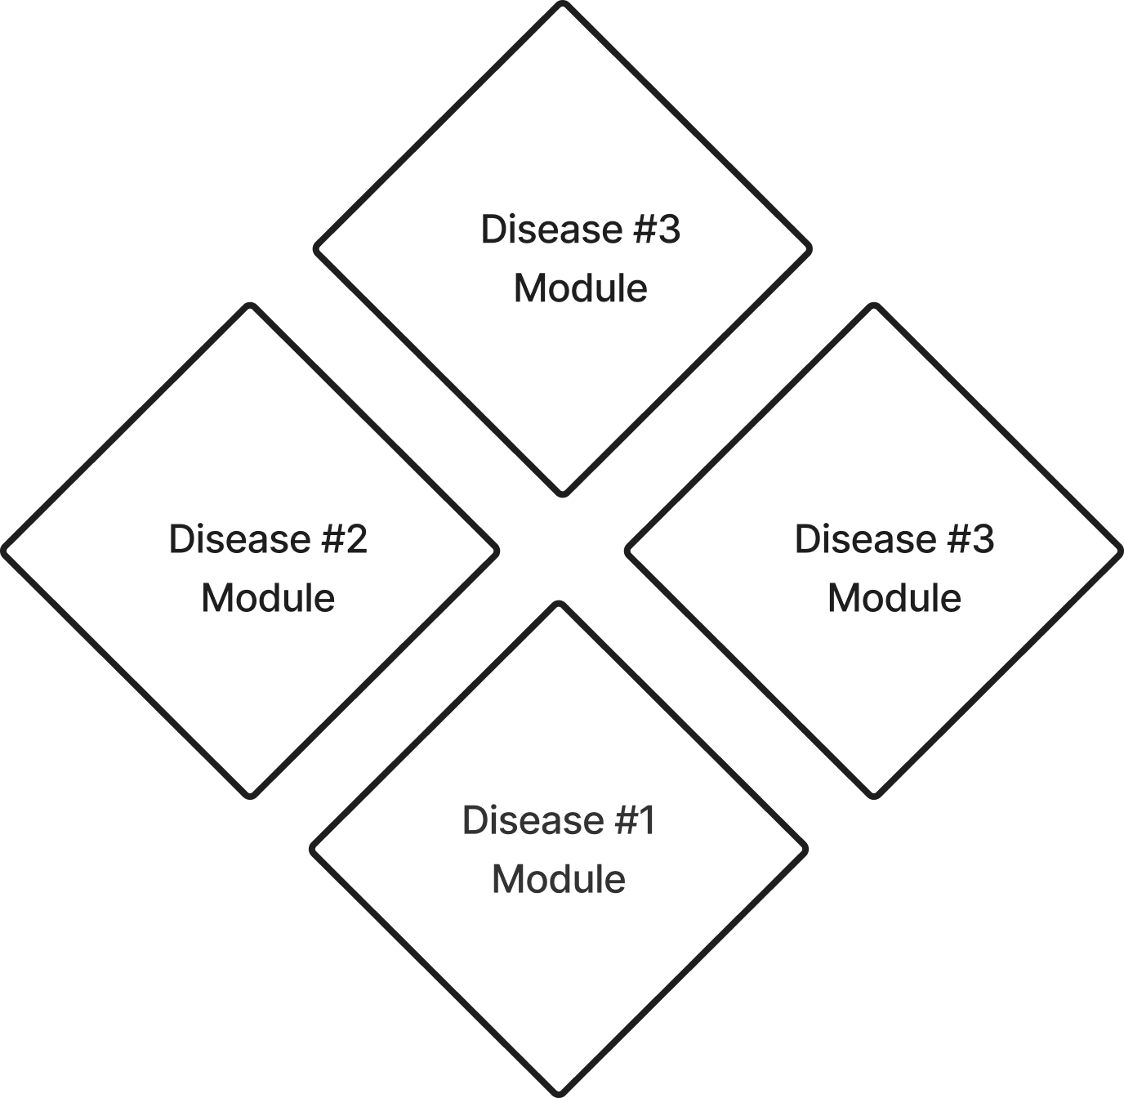

1. Modular DSES

Each ML model has the ability to stay isolated from all other decision making entities which allows them to be unbiased. Having such an abstraction creates opportunities to enhance only parts of the decision making system without affecting the working of the entire system.

## Decision Output

The thinking process behind the way we interpret a decision is only unique to our ability as humans because of our advanced linguistic capabilities. Hence if we are to create a recommendation system for diagnostic purposes based on algorithms then we are bound to enable better interpretations of the results without any loss of data.

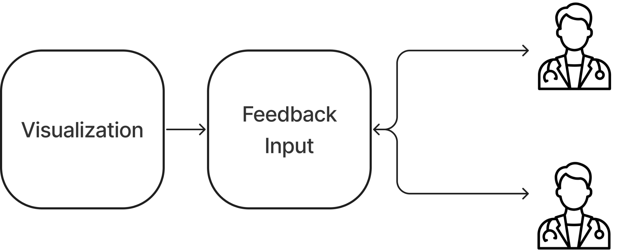

1. Output Module, Processes input from DDA for visualization.

This module enables us to convert algorithmically generated data into human understandable explanations. With the ability to form conclusions which we cannot fathom as to how they were made, the output must include a traceback that includes reasoning for each step in the decision making process. The output module is the interface between the architecture and the doctors. It also functions as the input to the feedback loop which actively fine tunes the specific parts of the architecture. By doing this the model is in a state of continuous innovation and is actively learning new relations in the data. As depicted in Fig. 5 the feedback loop can help optimize separate expert systems and the DDA to improve accuracy over all.

## Data Store Module

This module is responsible for systematically storing all the inputs in an organized manner for quick access by the DSES and other components of the system. The output data of the DDA is also stored for future reference and to implement transfer learning when enough data points exist.

The Data Store Module can hold image data using a file system, relational data using RDBMS and unstructured data using NoSQL database as per requirements. Fig. 6 gives an overview of the Data Store Module module.

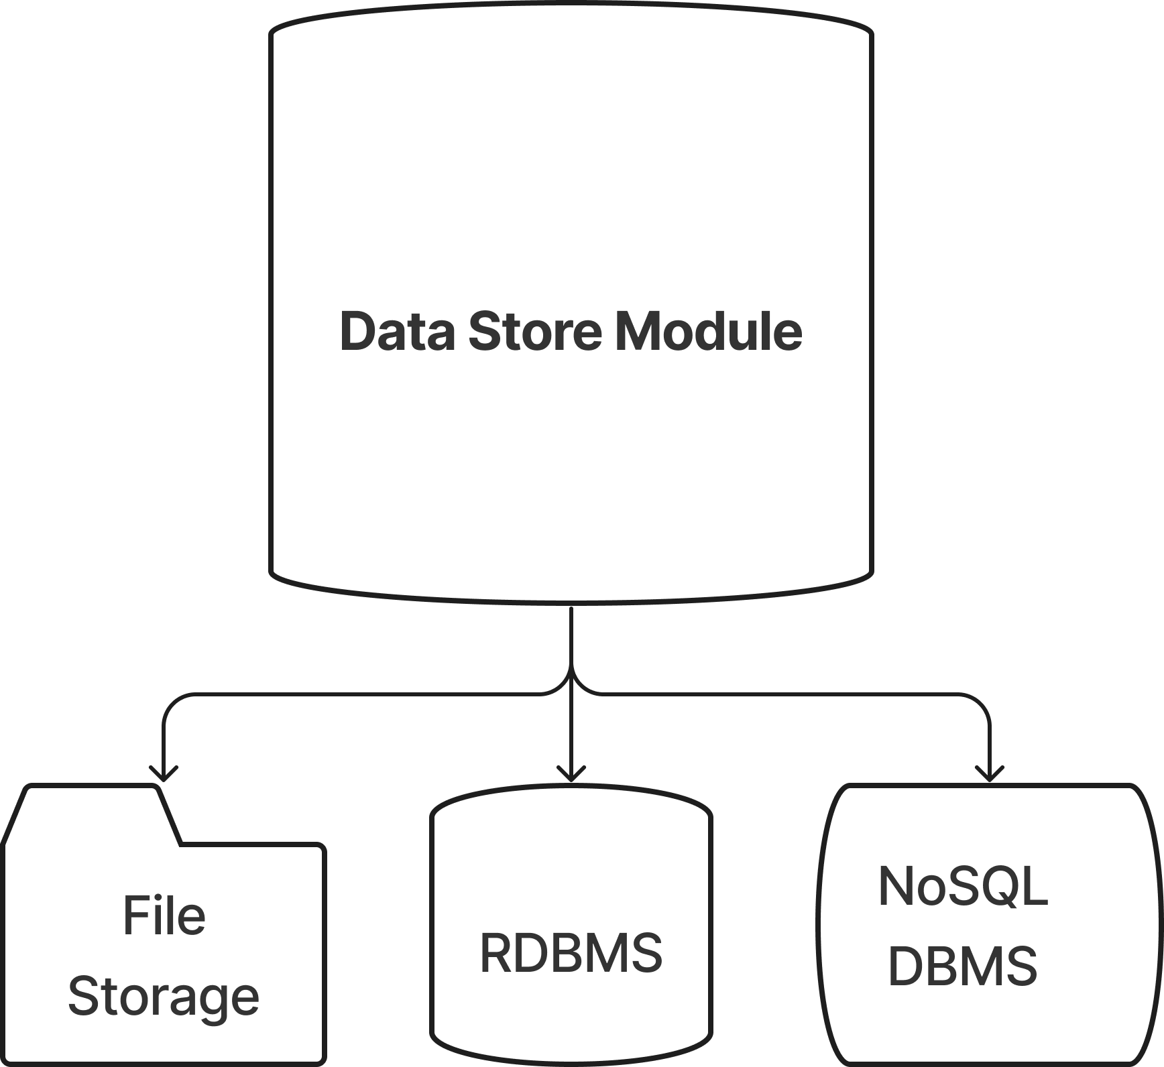

1. Data Store Module

# RESULTS AND DISCUSSION

Through our findings and research we have built a precise and relevant architecture that can be implemented in any environment easily. Our architecture includes the human AI interaction that plays an essential part in the analysis and is the key point of achieving a model that is not only dependent on the dataset and accepts real time inputs.

In addition to the points mentioned above our architecture is modular in nature and will work well on various categories of data, which makes it versatile. The architecture also considers various machine learning algorithms like clustering which is a method of organizing data points into separate clusters based on their similarity. The objects with possible similarities are kept in a group with few or no similarities to another. This machine learning technique has helped us achieve a system that simplifies the complex nature of analyzing sensitive data.

# CONCLUSION

AI technology has proven to be the most advanced innovation of humankind. It has taken over various sectors, it is about time that we leverage its functionalities to a field– medical, that is finding it hard to adapt to the latest technologies in the diagnosis sector. Diagnosis of a disease using AI involves various inputs and analysis which might overwhelm an individual but with the approach provided in this architecture, we can encourage more reliability in the system.

# REFERENCES

1. Amato, Filippo, et al. "Artificial neural networks in medical diagnosis." Journal of applied biomedicine 11.2 (2013): 47-58.
2. J. Lemley, S. Bazrafkan and P. Corcoran, "Smart Augmentation Learning an Optimal Data Augmentation Strategy," in IEEE Access, vol. 5, pp. 5858-5869, 2017, doi: 10.1109/ACCESS.2017.2696121.
3. Dongare, A. D., R. R. Kharde, and Amit D. Kachare. "Introduction to artificial neural network." International Journal of Engineering and Innovative Technology (IJEIT) 2.1 (2012): 189-194.
4. Kononenko, Igor. "Machine learning for medical diagnosis: history, state of the art and perspective." Artificial Intelligence in medicine 23.1 (2001): 89-109.
5. Park, Seong Ho, and Kyunghwa Han. "Methodologic guide for evaluating clinical performance and effect of artificial intelligence technology for medical diagnosis and prediction." Radiology 286.3 (2018): 800-809.